<https://pixabay.com/photos/begging-hands-poor-hope-charity-1922612/>



Free for use under the Pixabay [**Content License**](https://pixabay.com/service/license-summary/)

[](https://pixabay.com/users/truthseeker08-2411480/)

[**truthseeker08**](https://pixabay.com/users/truthseeker08-2411480/)1,541 followers

<https://pixabay.com/photos/people-homeless-male-street-850097/>



Free for use under the Pixabay [**Content License**](https://pixabay.com/service/license-summary/)

[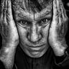](https://pixabay.com/users/leroy_skalstad-1202818/)

[**Leroy_Skalstad**](https://pixabay.com/users/leroy_skalstad-1202818/)1,624 followers

**Follow**

I LOVE COFFEE, "WINK"

<https://pixabay.com/photos/woman-desperation-loss-cover-3758052/>



[](https://pixabay.com/users/jerzygorecki-2233926/)

[**JerzyGorecki**](https://pixabay.com/users/jerzygorecki-2233926/)9,040 followers

<https://pixabay.com/photos/old-man-old-man-loneliness-1701640/>



Free for use under the Pixabay [**Content License**](https://pixabay.com/service/license-summary/)

[](https://pixabay.com/users/isakarakus-2336747/)

[**isakarakus**](https://pixabay.com/users/isakarakus-2336747/)697 followers

**Follow**

I love life.

<https://pixabay.com/photos/boy-poor-afraid-fear-sad-person-60710/>

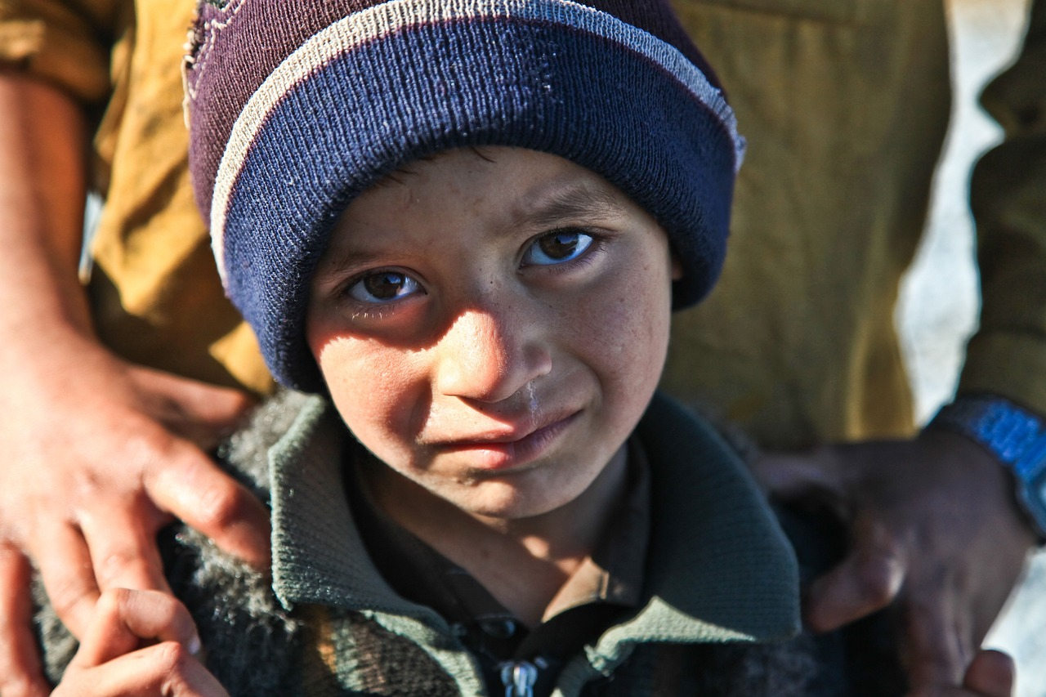

Free for use under the Pixabay [**Content License**](https://pixabay.com/service/license-summary/)

[](https://pixabay.com/users/armyamber-10439/)

[**ArmyAmber**](https://pixabay.com/users/armyamber-10439/)666 followers